
Hkkjrh; izkS|ksfxdh LkaLFkku iVuk
Indian Institute of Technology Patna
Department of Electrical Engineering
IIT Patna, Campus, Bihta, Patna, Bihar – 801103 Experiment No. 10

Two-Digit Frequency Counter

OBJECTIVE: Designing a two digit frequency counter showing the count values on two 7-segment displays.
COMPONENTS REQUIRED

: LED : one.
: 7-seg. Display : two (Common Anode)
: Resistance : two 330Ω, two 470Ω, one 10KΩ.
: Capacitor : one 1uF, one, 0.01 uF.
: ICs : one LM555, two 74LS00 (NAND gate), two 74LS93 (4-bit binary counter), two 74LS47.

PRECAUTIONS AND GUIDELINES
1. While switching on the set-up, switch on the oscilloscope first, then the power supply to the circuit, and finally the function generator. When switching off, follow the sequence in reverse order.

2. For any IC, never exceed the input voltage beyond the power supply limits.

3. Keep ground terminals of the oscilloscope probes and function generator output, and power supply common connected together throughout the experiment.

Working Principle:
This experiment is for counting the frequency of an input signal (given from Function Generator) for a single pulse duration using 2-digit BCD counters with 7-segement displays. For making 2-digit BCD counter you can use circuit from Exp. No. 9 (1- digit BCD Counter with 7-segment display) with some modifications.

The single pulse, during which input signal frequency will be counted, is being generated by using a IC555 timer chip as shown in figure 10.1. The 555 timer is operating in Monostable (or One-shot) mode i.e., it generates a single pulse at pin ‘3’
(Output pin) each time it receives an input trigger pulse (High to Low) at pin ‘2’ (Trigger pin). In a stable or standby state, the output of the circuit is approximately zero or a logic-low level. When external trigger pulse is applied, output is forced to go high (VCC). The time ‘T’ for which output remains high is determined by the external RC network connected to the timer and is given by T=1.1*R*C (second).

At the end of the timing interval, the output automatically reverts back to its logic-low stable state. The output stays low until trigger pulse is again applied. Then the cycle repeats.

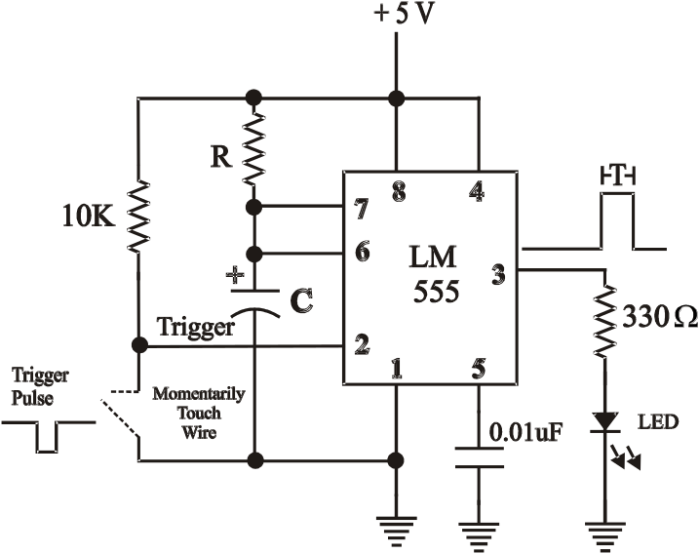

Fig. 10.1: Pulse generation using 555 Timer (Monostable Multivibrator).

OBSERVATIONS:
(A) Generation of Pulses:
1. Connect the circuit as shown in Fig. 10.1 in a bread-board.
2. Choose values of R & C to generate a single pulse of duration approx. T=1s at pin ‘3’. (Typical combinations of R
and C values are 1MΩ & 1uF, 100KΩ & 10uF, 10KΩ & 100uF etc..

3. Apply power (+5V) to the circuit. Make sure the power supply ground is connected to the circuit ground.

4. Now apply a Trigger pulse to pin ‘2’ (Trigger) using the push-button switch (SW1). If you are not using push-button switch then you can connect a short piece of hook-up wire to the Trigger input line on pin ‘2’. Momentarily, touch that wire to ground and remove it quickly. That will create a pulse at the trigger input.

5. Observe the pulse output at pin ‘3’. For each trigger pulse given at pin ‘2’, the output LED will glow for time period ‘T‘
and then it will be off.

(B) Counting of Input Signal Frequency (2-Digit display):

6. Now to count the input signal frequency for this pulse duration, connect this pulse output (designated as ‘X’) to one of the inputs of a NAND gate.

7. Apply the input signal from Function Generator (FG) to the other input of the NAND gate. The NAND gate output will act as clock signal for counter ‘CLKA’ input (pin 14) of the Exp. No. 9 (1-digit BCD Counter with 7-segment display). For your reference the circuit has been redrawn in fig 10.2.

8. Make this counter (say ‘Counter0’) a Mod-10(decade) counter. For this you can use other NAND gates of 7400

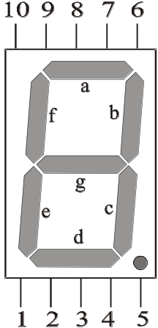
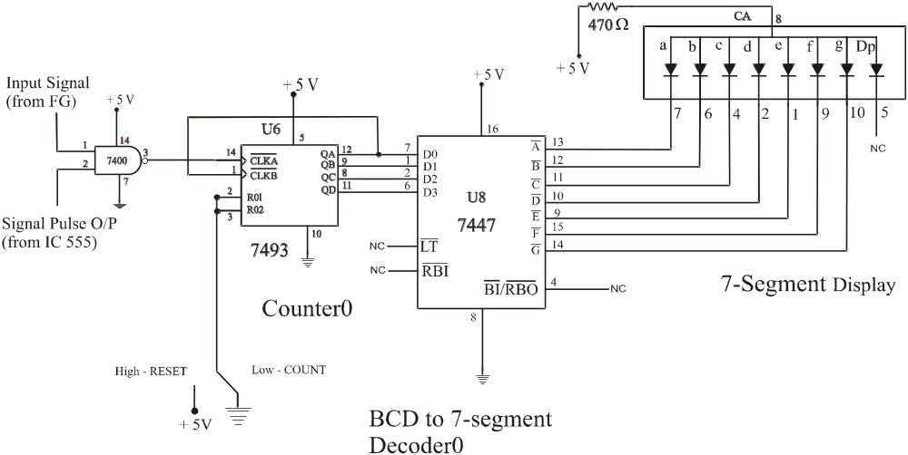

Fig. 10.2: 1-Digit BCD counter with 7-Segment display (from Exp. 9)

9. Now, to view the count values in 2-digits display (00 to 99), you have to use another set of IC7493 (say ‘Counter1’), IC7447 (say ‘Decoder1’) and 7-segment display (say ‘Display1’).

10. Make your own connections for extending the 1-digit BCD counter to 2-digits BCD counter.

11. Now, give trigger pulses at pin ‘2’ of 555 timer and accordingly observe the count values displayed in both the 7- segment displays.

----------------------------

